A

PROJECT REPORT

ON

**COVID_19 TRACKER APPLICATION**

DESIGNED AND DEVELOPED

BY:

**Mrs. SINGH UTTAM PRAMOD**

AND GUIDED

BY:

**PROF.SUMATHI R.**



[BACHELOR OF SCIENCE COMPUTER SCIENCE]

[UNIVERSITY OF MUMBAI]

**ACKNOWLEDGEMENT**

**ACKNOWLEDGEMENT**

I would like to express my special thanks of gratitude to my teacher, **PROF.SUMATHI R**.who gave me the golden opportunity to do this wonderful project on the topic **COVID_19 TRACKER APPLICATION**, which also helped me in doing a lot of Research and I came to know about so many new things I am really thankful to them.

Secondly I would also like to thank my parents and friends who helped me a lot in finalizing this project within the limited time

**SINGH UTTAM PRAMOD**

**DECLARATION**

I,**”SINGH UTTAM PRAMOD”**, hereby declare that I myself have completed this project under the guidance of **Prof. SUMATHI.R** . I on my own have designed the system and have done all the programming required.

It may require some modification in the future as per the user’s requirements. From the practical implementation point of view, flexibility in the changes has been incorporated in the package.

I am sure that I can do any kind of modification suggested while practical implementation by modifying files design or the program code if necessary.

**INDEX**

|  |  |  |
| --- | --- | --- |
| **Sr. No.** | **Topic** | **Page No.** |
| 1. | About the Project |  |
| 2. | System Requirement |  |
| 3. | Use Case Diagram |  |
| 4. | System Coding |  |
| 5. | User Interface |  |
| 6. | Future Enhancements |  |
| 7. | Reference and Bibliography |  |

**ABOUT THE PROJECT**

# ABSTRACT

# THE MAIN OBJECTIVE FOR CREATING THIS SPECIFIC PROJECT TO DISPLAY THE WORLD WIDE GRAPHICAL & NUMERICAL REPRESENTATION OF COVID_19 CASES.

# IT WILL DISPLAY THE TOTAL CASES, RECOVERD, DEATH AND ACTIVE CASES IN PIE CHART.

# MOTIVATION

# THIS WILL DIRECTLY HELP INDIVISUAL TO TRACK THE COVID_19 CASES BY COUNTRY WIDE.

# IT ALSO HELP TO MONITOR THE RECOVERD, DEATH AND ACTIVE CASES.

**MODULES:**

* **SPLASH SCREEN:** IT DISPLAY THE DEVELOPER NAME AND GOES TO THE HOMEPAGE.
* **HOMEPAGE:** THIS MODULE IS THE FIRST PAGE OF THE APP THAT THE USERS WILL VIEW THE PIE CHART AND GLOBAL STATS.
* **REFRESH:** AT RIGHT TOP CORNER THERE IS THE REFRESH BUTTON WHICH HELPS TO GET THE REAL TIME DATA.
* **TRACK COUNTRIES:** IT DISPLAY THE NUMBER OF COVID 19 CASES BY COUNTRY.

**FACILITIES REQUIRED FOR PROPOSED PROJECT:**

* **SOFTWARE REQUIREMENTS:**
* ANDROID STUDIO RUNNING ON WINDOWS 7 OR 10 .
* **HARDWARE REQUIREMENTS:**
* STANDARD DESKTOP OR LAPTOP RUNNING WINDOWS 7 OR ABOVE.
* RAM: 4 GB OR ABOVE. (8 GB USED WHILE DEVELOPMENT)
* COLOR MONITOR FOR VIEWING
* KEYBOARD AND MOUSE FOR NAVIGATION.

USE CASE DIAGRAM

**USE CASE DIAGRAM FOR USER :**

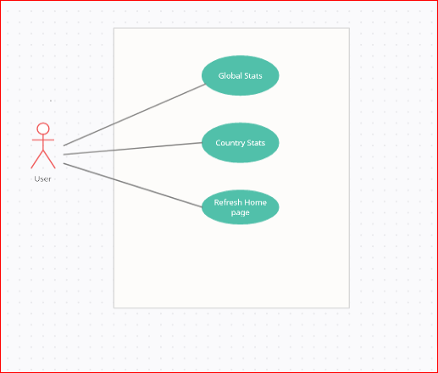

System coding

**Activity_main.xml:**

*<?***xml version="1.0" encoding="utf-8"***?>*<**RelativeLayout xmlns:android="http://schemas.android.com/apk/res/android"  
 xmlns:app="http://schemas.android.com/apk/res-auto"  
 xmlns:tools="http://schemas.android.com/tools"  
 android:layout_width="match_parent"  
 android:background="@color/color_white"  
 android:layout_height="match_parent"  
 tools:context=".MainActivity"**>  
  
 <**androidx.cardview.widget.CardView  
 android:layout_width="match_parent"  
 android:layout_height="180dp"  
 android:layout_marginLeft="20dp"  
 android:id="@+id/cardViewGraph"  
 android:layout_marginRight="20dp"  
 android:layout_marginTop="20dp"  
 app:cardElevation="10dp"  
 app:cardCornerRadius="20dp"** >  
  
 <**LinearLayout  
 android:layout_width="match_parent"  
 android:layout_height="match_parent"  
 android:orientation="horizontal"  
 android:weightSum="2"** >  
 <**org.eazegraph.lib.charts.PieChart  
 android:layout_width="0dp"  
 android:layout_height="match_parent"  
 android:padding="5dp"  
 android:layout_marginTop="15dp"  
 android:layout_marginRight="15dp"  
 android:layout_marginLeft="15dp"  
 android:layout_marginBottom="15dp"  
 android:id="@+id/piechart"  
 android:layout_weight="1"**></**org.eazegraph.lib.charts.PieChart**>  
  
 <**LinearLayout  
 android:layout_width="0dp"  
 android:layout_height="match_parent"  
 android:layout_weight="1"  
 android:layout_marginLeft="20dp"  
 android:orientation="vertical"  
 android:gravity="center_vertical"**>  
 <**LinearLayout  
 android:layout_width="match_parent"  
 android:layout_height="15dp"  
 android:gravity="center_vertical"** >  
 <**View  
 android:layout_width="15dp"  
 android:layout_height="match_parent"  
 android:background="@color/cases"** />  
 <**TextView  
 android:layout_width="wrap_content"  
 android:layout_height="wrap_content"  
 android:text="Total Cases"  
 android:textStyle="bold"  
 android:paddingLeft="20dp"** />  
 </**LinearLayout**>  
 <**LinearLayout  
 android:layout_width="match_parent"  
 android:layout_height="15dp"  
 android:layout_marginTop="10dp"  
 android:gravity="center_vertical"** >  
 <**View  
 android:layout_width="15dp"  
 android:layout_height="match_parent"  
 android:background="@color/recovered"** />  
 <**TextView  
 android:layout_width="wrap_content"  
 android:layout_height="wrap_content"  
 android:text="Recoverd"  
 android:textStyle="bold"  
 android:paddingLeft="20dp"** />  
 </**LinearLayout**>  
 <**LinearLayout  
 android:layout_width="match_parent"  
 android:layout_height="15dp"  
 android:layout_marginTop="10dp"  
 android:gravity="center_vertical"** >  
 <**View  
 android:layout_width="15dp"  
 android:layout_height="match_parent"  
 android:background="@color/death"** />  
 <**TextView  
 android:layout_width="wrap_content"  
 android:layout_height="wrap_content"  
 android:text="Death"  
 android:textStyle="bold"  
 android:paddingLeft="20dp"** />  
 </**LinearLayout**>  
 <**LinearLayout  
 android:layout_width="match_parent"  
 android:layout_height="15dp"  
 android:layout_marginTop="10dp"  
 android:gravity="center_vertical"** >  
 <**View  
 android:layout_width="15dp"  
 android:layout_height="match_parent"  
 android:background="@color/active"** />  
 <**TextView  
 android:layout_width="wrap_content"  
 android:layout_height="wrap_content"  
 android:text="Active"  
 android:textStyle="bold"  
 android:paddingLeft="20dp"** />  
 </**LinearLayout**>  
 </**LinearLayout**>  
 </**LinearLayout**>  
  
 </**androidx.cardview.widget.CardView**>  
  
 <**androidx.cardview.widget.CardView  
 android:layout_width="match_parent"  
 android:layout_height="fill_parent"  
 android:layout_below="@+id/cardViewGraph"  
 android:layout_above="@+id/button"  
 android:layout_marginLeft="20dp"  
 android:layout_marginRight="20dp"  
 android:layout_marginTop="20dp"  
 app:cardElevation="10dp"  
 app:cardCornerRadius="20dp"** >  
  
 <**RelativeLayout  
 android:layout_width="match_parent"  
 android:layout_height="match_parent"** >  
 <**com.leo.simplearcloader.SimpleArcLoader  
  
 android:id="@+id/loader"  
 android:layout_centerInParent="true"  
 android:layout_height="60dp"  
 android:layout_width="60dp"  
 app:arc_style="simple_arc"  
 android:visibility="visible"** >  
  
 </**com.leo.simplearcloader.SimpleArcLoader**>  
  
 <**ScrollView  
 android:layout_width="match_parent"  
 android:layout_height="match_parent"  
 android:id="@+id/scrollstats"  
 android:visibility="gone"** >  
  
 <**LinearLayout  
 android:layout_width="match_parent"  
 android:layout_height="wrap_content"  
 android:orientation="vertical"** >  
  
 <**TextView  
 android:layout_width="match_parent"  
 android:layout_height="wrap_content"  
 android:text="GlOBAL STATS"  
 android:textAllCaps="true"  
 android:textSize="28sp"  
 android:textStyle="bold"  
 android:layout_marginLeft="29dp"  
 android:layout_marginTop="20dp"**/>  
 <**View  
 android:layout_width="match_parent"  
 android:layout_height="1dp"  
 android:background="@color/color_two"  
 android:layout_marginLeft="20dp"  
 android:layout_marginRight="20dp"  
 android:layout_marginTop="5dp"**/>  
 <**RelativeLayout  
 android:layout_width="match_parent"  
 android:layout_height="wrap_content"  
 android:layout_marginRight="25dp"  
 android:layout_marginLeft="25dp"  
 android:layout_marginTop="10dp"  
 android:layout_marginBottom="10dp"** >  
  
 <**TextView  
 android:layout_width="wrap_content"  
 android:layout_height="wrap_content"  
 android:fontFamily="sans-serif-light"  
 android:text="Cases"  
 android:textSize="18sp"  
 android:textStyle="bold"**/>  
 <**TextView  
 android:layout_width="fill_parent"  
 android:layout_height="wrap_content"  
 android:text="0"  
 android:id="@+id/tvcases"  
 android:layout_alignParentEnd="true"  
 android:textSize="18sp"  
 android:textAlignment="textEnd"  
 android:textStyle="bold"**/>  
 </**RelativeLayout**>  
 <**View  
 android:layout_width="match_parent"  
 android:layout_height="1dp"  
 android:background="@color/color_two"  
 android:layout_marginLeft="20dp"  
 android:layout_marginRight="20dp"  
 android:layout_marginTop="5dp"**/>  
  
 <**RelativeLayout  
 android:layout_width="match_parent"  
 android:layout_height="wrap_content"  
 android:layout_marginRight="25dp"  
 android:layout_marginLeft="25dp"  
 android:layout_marginTop="10dp"  
 android:layout_marginBottom="10dp"** >  
  
 <**TextView  
 android:layout_width="wrap_content"  
 android:layout_height="wrap_content"  
 android:fontFamily="sans-serif-light"  
 android:text="Recovered"  
 android:textSize="18sp"  
 android:textStyle="bold"**/>  
 <**TextView  
 android:layout_width="fill_parent"  
 android:layout_height="wrap_content"  
 android:text="0"  
 android:id="@+id/tvrecovered"  
 android:layout_alignParentEnd="true"  
 android:textSize="18sp"  
 android:textAlignment="textEnd"  
 android:textStyle="bold"**/>  
 </**RelativeLayout**>  
 <**View  
 android:layout_width="match_parent"  
 android:layout_height="1dp"  
 android:background="@color/color_two"  
 android:layout_marginLeft="20dp"  
 android:layout_marginRight="20dp"  
 android:layout_marginTop="5dp"**/>  
 <**RelativeLayout  
 android:layout_width="match_parent"  
 android:layout_height="wrap_content"  
 android:layout_marginRight="25dp"  
 android:layout_marginLeft="25dp"  
 android:layout_marginTop="10dp"  
 android:layout_marginBottom="10dp"** >  
  
 <**TextView  
 android:layout_width="wrap_content"  
 android:layout_height="wrap_content"  
 android:fontFamily="sans-serif-light"  
 android:text="Critical"  
 android:textSize="18sp"  
 android:textStyle="bold"**/>  
 <**TextView  
 android:layout_width="fill_parent"  
 android:layout_height="wrap_content"  
 android:text="0"  
 android:id="@+id/tvcritical"  
 android:layout_alignParentEnd="true"  
 android:textSize="18sp"  
 android:textAlignment="textEnd"  
 android:textStyle="bold"**/>  
 </**RelativeLayout**>  
 <**View  
 android:layout_width="match_parent"  
 android:layout_height="1dp"  
 android:background="@color/color_two"  
 android:layout_marginLeft="20dp"  
 android:layout_marginRight="20dp"  
 android:layout_marginTop="5dp"**/>  
 <**RelativeLayout  
 android:layout_width="match_parent"  
 android:layout_height="wrap_content"  
 android:layout_marginRight="25dp"  
 android:layout_marginLeft="25dp"  
 android:layout_marginTop="10dp"  
 android:layout_marginBottom="10dp"** >  
  
 <**TextView  
 android:layout_width="wrap_content"  
 android:layout_height="wrap_content"  
 android:fontFamily="sans-serif-light"  
 android:text="Active"  
 android:textSize="18sp"  
 android:textStyle="bold"**/>  
 <**TextView  
 android:layout_width="fill_parent"  
 android:layout_height="wrap_content"  
 android:text="0"  
 android:id="@+id/tvactive"  
 android:layout_alignParentEnd="true"  
 android:textSize="18sp"  
 android:textAlignment="textEnd"  
 android:textStyle="bold"**/>  
 </**RelativeLayout**>  
 <**View  
 android:layout_width="match_parent"  
 android:layout_height="1dp"  
 android:background="@color/color_two"  
 android:layout_marginLeft="20dp"  
 android:layout_marginRight="20dp"  
 android:layout_marginTop="5dp"**/>  
 <**RelativeLayout  
 android:layout_width="match_parent"  
 android:layout_height="wrap_content"  
 android:layout_marginRight="25dp"  
 android:layout_marginLeft="25dp"  
 android:layout_marginTop="10dp"  
 android:layout_marginBottom="10dp"** >  
  
 <**TextView  
 android:layout_width="wrap_content"  
 android:layout_height="wrap_content"  
 android:fontFamily="sans-serif-light"  
 android:text="Today Cases"  
 android:textSize="18sp"  
 android:textStyle="bold"**/>  
 <**TextView  
 android:layout_width="fill_parent"  
 android:layout_height="wrap_content"  
 android:text="0"  
 android:id="@+id/tvtotalcases"  
 android:layout_alignParentEnd="true"  
 android:textSize="18sp"  
 android:textAlignment="textEnd"  
 android:textStyle="bold"**/>  
 </**RelativeLayout**>  
 <**View  
 android:layout_width="match_parent"  
 android:layout_height="1dp"  
 android:background="@color/color_two"  
 android:layout_marginLeft="20dp"  
 android:layout_marginRight="20dp"  
 android:layout_marginTop="5dp"**/>  
 <**RelativeLayout  
 android:layout_width="match_parent"  
 android:layout_height="wrap_content"  
 android:layout_marginRight="25dp"  
 android:layout_marginLeft="25dp"  
 android:layout_marginTop="10dp"  
 android:layout_marginBottom="10dp"** >  
  
 <**TextView  
 android:layout_width="wrap_content"  
 android:layout_height="wrap_content"  
 android:fontFamily="sans-serif-light"  
 android:text="Total Death"  
 android:textSize="18sp"  
 android:textStyle="bold"**/>  
 <**TextView  
 android:layout_width="fill_parent"  
 android:layout_height="wrap_content"  
 android:text="0"  
 android:id="@+id/tvtotaldeath"  
 android:layout_alignParentEnd="true"  
 android:textSize="18sp"  
 android:textAlignment="textEnd"  
 android:textStyle="bold"**/>  
 </**RelativeLayout**>  
 <**View  
 android:layout_width="match_parent"  
 android:layout_height="1dp"  
 android:background="@color/color_two"  
 android:layout_marginLeft="20dp"  
 android:layout_marginRight="20dp"  
 android:layout_marginTop="5dp"**/>  
 <**RelativeLayout  
 android:layout_width="match_parent"  
 android:layout_height="wrap_content"  
 android:layout_marginRight="25dp"  
 android:layout_marginLeft="25dp"  
 android:layout_marginTop="10dp"  
 android:layout_marginBottom="10dp"** >  
  
 <**TextView  
 android:layout_width="wrap_content"  
 android:layout_height="wrap_content"  
 android:fontFamily="sans-serif-light"  
 android:text="Today Death"  
 android:textSize="18sp"  
 android:textStyle="bold"**/>  
 <**TextView  
 android:layout_width="fill_parent"  
 android:layout_height="wrap_content"  
 android:text="0"  
 android:id="@+id/tvtodaydeath"  
 android:layout_alignParentEnd="true"  
 android:textSize="18sp"  
 android:textAlignment="textEnd"  
 android:textStyle="bold"**/>  
 </**RelativeLayout**>  
 <**View  
 android:layout_width="match_parent"  
 android:layout_height="1dp"  
 android:background="@color/color_two"  
 android:layout_marginLeft="20dp"  
 android:layout_marginRight="20dp"  
 android:layout_marginTop="5dp"**/>  
 <**RelativeLayout  
 android:layout_width="match_parent"  
 android:layout_height="wrap_content"  
 android:layout_marginRight="25dp"  
 android:layout_marginLeft="25dp"  
 android:layout_marginTop="10dp"  
 android:layout_marginBottom="10dp"** >  
  
 <**TextView  
 android:layout_width="wrap_content"  
 android:layout_height="wrap_content"  
 android:fontFamily="sans-serif-light"  
 android:text="Affected Countries"  
 android:textSize="18sp"  
 android:textStyle="bold"**/>  
 <**TextView  
 android:layout_width="fill_parent"  
 android:layout_height="wrap_content"  
 android:text="0"  
 android:id="@+id/tvaffectedcountry"  
 android:layout_alignParentEnd="true"  
 android:textSize="18sp"  
 android:textAlignment="textEnd"  
 android:textStyle="bold"**/>  
 </**RelativeLayout**>  
 <**View  
 android:layout_width="match_parent"  
 android:layout_height="1dp"  
 android:background="@color/color_two"  
 android:layout_marginLeft="20dp"  
 android:layout_marginRight="20dp"  
 android:layout_marginTop="5dp"**/>  
  
  
  
 </**LinearLayout**>  
 </**ScrollView**>  
  
 </**RelativeLayout**>  
 </**androidx.cardview.widget.CardView**>  
  
  
 <**Button  
 android:id="@+id/button"  
 android:layout_width="match_parent"  
 android:layout_height="wrap_content"  
 android:layout_alignParentBottom="true"  
 android:layout_centerHorizontal="true"  
 android:layout_margin="20dp"  
 android:background="@color/color_one"  
 android:text="Track Countries"** />  
  
  
  
</**RelativeLayout**>

**MainActivity.java :**

**package** com.example.covid_19tracker;  
  
**import** androidx.annotation.NonNull;  
**import** androidx.appcompat.app.AppCompatActivity;  
  
**import** android.content.Intent;  
**import** android.graphics.Color;  
**import** android.os.Bundle;  
**import** android.view.Menu;  
**import** android.view.MenuInflater;  
**import** android.view.MenuItem;  
**import** android.view.View;  
**import** android.widget.Button;  
**import** android.widget.ScrollView;  
**import** android.widget.TextView;  
**import** android.widget.Toast;  
  
**import** com.android.volley.Request;  
**import** com.android.volley.RequestQueue;  
**import** com.android.volley.Response;  
**import** com.android.volley.VolleyError;  
**import** com.android.volley.toolbox.StringRequest;  
**import** com.android.volley.toolbox.Volley;  
**import** com.leo.simplearcloader.SimpleArcLoader;  
  
**import** org.eazegraph.lib.charts.PieChart;  
**import** org.eazegraph.lib.models.PieModel;  
**import** org.json.JSONException;  
**import** org.json.JSONObject;  
  
**public class** MainActivity **extends** AppCompatActivity {  
  
 TextView **tvcases**,**tvrecovered**,**tvcritical**,**tvactive**,**tvtodaycases**,**tvtodaydeath**,**tvtotaldeath**,**tvaffectedcountry**;  
 ScrollView **scrollView**;  
 PieChart **pieChart**;  
 SimpleArcLoader **simpleArcLoader**;  
 Button **btn**;  
  
 @Override  
 **protected void** onCreate(Bundle savedInstanceState) {  
 **super**.onCreate(savedInstanceState);  
 setContentView(R.layout.***activity_main***);  
  
  
  
 **tvcases**=findViewById(R.id.***tvcases***);  
 **tvrecovered**=findViewById(R.id.***tvrecovered***);  
 **tvcritical**=findViewById(R.id.***tvcritical***);  
 **tvactive**=findViewById(R.id.***tvactive***);  
 **tvtodaycases**=findViewById(R.id.***tvtotalcases***);  
 **tvtodaydeath**=findViewById(R.id.***tvtodaydeath***);  
 **tvtotaldeath**=findViewById(R.id.***tvtotaldeath***);  
 **tvaffectedcountry**=findViewById(R.id.***tvaffectedcountry***);  
 **scrollView**=findViewById(R.id.***scrollstats***);  
 **pieChart**=findViewById(R.id.***piechart***);  
 **simpleArcLoader**=findViewById(R.id.***loader***);  
 **btn**=findViewById(R.id.***button***);  
  
 fetchdata();  
  
  
 **btn**.setOnClickListener(**new** View.OnClickListener() {  
 @Override  
 **public void** onClick(View v) {  
  
 startActivity(**new** Intent(getApplicationContext(),AffectedCountries.**class**));  
  
  
  
 }  
 });  
  
  
  
  
  
  
 }  
  
 @Override  
 **public boolean** onCreateOptionsMenu(Menu menu) {  
 MenuInflater menuInflater=getMenuInflater();  
 menuInflater.inflate(R.menu.***menu***,menu);  
 **return super**.onCreateOptionsMenu(menu);  
 }  
  
 @Override  
 **public boolean** onOptionsItemSelected(@NonNull MenuItem item) {  
 **switch** (item.getItemId())  
 {  
 **case** R.id.***menurefresh***:  
 **pieChart**.clearChart();  
 fetchdata();  
 **break**;  
 }  
 **return super**.onOptionsItemSelected(item);  
 }  
  
 **private void** fetchdata() {  
  
 String url=**"https:corona.lmao.ninja/v2/all/"**;  
 **simpleArcLoader**.start();  
  
 StringRequest request=**new** StringRequest(Request.Method.***GET***, url, **new** Response.Listener<String>() {  
 @Override  
 **public void** onResponse(String response) {  
  
 **try** {  
 JSONObject jsonObject=**new** JSONObject(response.toString());  
  
 **tvcases**.setText(jsonObject.getString(**"cases"**));  
 **tvrecovered**.setText(jsonObject.getString(**"recovered"**));  
 **tvcritical**.setText(jsonObject.getString(**"critical"**));  
 **tvactive**.setText(jsonObject.getString(**"active"**));  
 **tvtodaycases**.setText(jsonObject.getString(**"todayCases"**));  
 **tvtotaldeath**.setText(jsonObject.getString(**"deaths"**));  
 **tvtodaydeath**.setText(jsonObject.getString(**"todayDeaths"**));  
 **tvaffectedcountry**.setText(jsonObject.getString(**"affectedCountries"**));  
  
  
 **pieChart**.addPieSlice(**new** PieModel(**"Cases"**,Integer.*parseInt*(**tvcases**.getText().toString()), Color.*parseColor*(**"#FFA726"**)));  
 **pieChart**.addPieSlice(**new** PieModel(**"Recovered"**,Integer.*parseInt*(**tvrecovered**.getText().toString()), Color.*parseColor*(**"#66BB6A"**)));  
 **pieChart**.addPieSlice(**new** PieModel(**"Death"**,Integer.*parseInt*(**tvtotaldeath**.getText().toString()), Color.*parseColor*(**"#EF5350"**)));  
 **pieChart**.addPieSlice(**new** PieModel(**"Active"**,Integer.*parseInt*(**tvactive**.getText().toString()), Color.*parseColor*(**"#29B6F6"**)));  
 **pieChart**.startAnimation();  
 **simpleArcLoader**.stop();  
 **simpleArcLoader**.setVisibility(View.***GONE***);  
  
 **scrollView**.setVisibility(View.***VISIBLE***);  
  
 } **catch** (JSONException e) {  
 e.printStackTrace();  
 **simpleArcLoader**.stop();  
 **simpleArcLoader**.setVisibility(View.***GONE***);  
 **scrollView**.setVisibility(View.***VISIBLE***);  
  
  
 }  
  
  
 }  
 }, **new** Response.ErrorListener() {  
 @Override  
 **public void** onErrorResponse(VolleyError error) {  
 **simpleArcLoader**.stop();  
 **simpleArcLoader**.setVisibility(View.***GONE***);  
 **scrollView**.setVisibility(View.***VISIBLE***);  
  
 Toast.*makeText*(MainActivity.**this**, error.getMessage(), Toast.***LENGTH_SHORT***).show();  
 }  
 });  
  
 RequestQueue requestQueue= Volley.*newRequestQueue*(**this**);  
 requestQueue.add(request);  
  
  
  
  
 }  
}

**Activity.splashscreen.xml**

*<?***xml version="1.0" encoding="utf-8"***?>*<**RelativeLayout xmlns:android="http://schemas.android.com/apk/res/android"  
 xmlns:app="http://schemas.android.com/apk/res-auto"  
 xmlns:tools="http://schemas.android.com/tools"  
 android:layout_width="match_parent"  
 android:layout_height="match_parent"  
  
 tools:context=".splashscreen"**>  
  
 <**ImageView  
 android:layout_width="250dp"  
 android:layout_height="wrap_content"  
 android:layout_centerInParent="true"  
 android:src="@drawable/splash"  
 android:layout_marginTop="10dp"  
 android:id="@+id/splash"** ></**ImageView**>  
  
 <**TextView  
 android:layout_width="wrap_content"  
 android:layout_height="wrap_content"  
 android:text="Devloped By Manish Maurya"  
 android:layout_alignBottom="@+id/splash"  
 android:layout_centerInParent="true"  
 android:textStyle="normal"  
 android:textSize="20dp"**></**TextView**>  
  
</**RelativeLayout**>

**Splashscreen.java:**

**package** com.example.covid_19tracker;  
  
**import** androidx.appcompat.app.AppCompatActivity;  
  
**import** android.content.Intent;  
**import** android.os.Bundle;  
**import** android.os.Handler;  
**import** android.view.animation.RotateAnimation;  
**import** android.widget.ImageView;  
  
**public class** splashscreen **extends** AppCompatActivity {  
  
  
  
 @Override  
 **protected void** onCreate(Bundle savedInstanceState) {  
 **super**.onCreate(savedInstanceState);  
 setContentView(R.layout.activity_splashscreen);  
  
  
 **new** Handler().postDelayed(**new** Runnable() {  
  
  
 @Override  
 **public void** run() {  
  
  
 Intent i = **new** Intent(splashscreen.**this**, MainActivity.**class**);  
 startActivity(i);  
  
  
 finish();  
  
 }  
 }, 3000);  
  
  
 }  
}

**Activity_affected_Country.xml**

*<?***xml version="1.0" encoding="utf-8"***?>*<**RelativeLayout xmlns:android="http://schemas.android.com/apk/res/android"  
 xmlns:app="http://schemas.android.com/apk/res-auto"  
 xmlns:tools="http://schemas.android.com/tools"  
 android:layout_width="match_parent"  
 android:layout_height="match_parent"  
 android:background="@color/color_white"  
 tools:context=".AffectedCountries"**>  
  
  
 <**ListView  
 android:layout_width="match_parent"  
 android:layout_height="fill_parent"  
 android:id="@+id/listview"  
 android:layout_margin="10dp"**></**ListView**>  
  
  
 <**com.leo.simplearcloader.SimpleArcLoader  
  
 android:id="@+id/loader1"  
 android:layout_centerInParent="true"  
 android:layout_height="60dp"  
 android:layout_width="60dp"  
 app:arc_style="simple_arc"** >  
  
 </**com.leo.simplearcloader.SimpleArcLoader**>  
  
  
</**RelativeLayout**>

**Affected_Country.java**

**package** com.example.covid_19tracker;  
  
**import** androidx.annotation.NonNull;  
**import** androidx.appcompat.app.AppCompatActivity;  
  
**import** android.content.Intent;  
**import** android.graphics.Color;  
**import** android.os.Bundle;  
**import** android.view.Menu;  
**import** android.view.MenuInflater;  
**import** android.view.MenuItem;  
**import** android.view.View;  
**import** android.widget.AdapterView;  
**import** android.widget.ArrayAdapter;  
**import** android.widget.EditText;  
**import** android.widget.ListView;  
**import** android.widget.Toast;  
  
**import** com.android.volley.Request;  
**import** com.android.volley.RequestQueue;  
**import** com.android.volley.Response;  
**import** com.android.volley.VolleyError;  
**import** com.android.volley.toolbox.JsonArrayRequest;  
**import** com.android.volley.toolbox.StringRequest;  
**import** com.android.volley.toolbox.Volley;  
**import** com.leo.simplearcloader.SimpleArcLoader;  
**import** org.json.JSONArray;  
**import** org.json.JSONException;  
**import** org.json.JSONObject;  
**import** java.util.ArrayList;  
**import** java.util.List;  
  
**public class** AffectedCountries **extends** AppCompatActivity {  
  
 ListView **listView**;  
 SimpleArcLoader **simpleArcLoader**;  
  
 **public static** List<Countrymodel> *countryModelList* =**new** ArrayList<>();  
 Countrymodel **countrymodel**;  
 MyCustomAdapter **myCustomAdapter**;  
  
  
  
  
  
  
  
 @Override  
 **protected void** onCreate(Bundle savedInstanceState) {  
 **super**.onCreate(savedInstanceState);  
 setContentView(R.layout.***activity_affected_countries***);  
  
 **listView**=findViewById(R.id.***listview***);  
 **simpleArcLoader**=findViewById(R.id.***loader1***);  
  
 getSupportActionBar().setTitle(**"Affected Countries"**);  
 getSupportActionBar().setDisplayHomeAsUpEnabled(**true**);  
 getSupportActionBar().setDisplayHomeAsUpEnabled(**true**);  
  
  
  
 fetchdata();  
  
  
 **listView**.setOnItemClickListener(**new** AdapterView.OnItemClickListener() {  
 @Override  
 **public void** onItemClick(AdapterView<?> parent, View view, **int** position, **long** id) {  
 startActivity(**new** Intent(getApplicationContext(),DetailsActiviy.**class**).putExtra(**"position"**,position));  
 }  
 });  
  
 }  
  
  
  
  
 **private void** fetchdata() {  
  
 String url=**"https:corona.lmao.ninja/v2/countries/"**;  
 **simpleArcLoader**.start();  
  
 StringRequest request=**new** StringRequest(Request.Method.***GET***, url, **new** Response.Listener<String>() {  
 @Override  
 **public void** onResponse(String response) {  
  
 **try** {  
 JSONArray jsonArray=**new** JSONArray(response);  
  
 **for** (**int** i=0;i<jsonArray.length();i++)  
 {  
 JSONObject jsonObject=jsonArray.getJSONObject(i);  
 String countryName=(jsonObject.getString(**"country"**));  
 String cases=(jsonObject.getString(**"cases"**));  
 String critical=(jsonObject.getString(**"critical"**));  
 String active=(jsonObject.getString(**"active"**));  
 String todayCases=(jsonObject.getString(**"todayCases"**));  
 String deaths=(jsonObject.getString(**"deaths"**));  
 String todayDeaths=(jsonObject.getString(**"todayDeaths"**));  
 String recovered=(jsonObject.getString(**"recovered"**));  
  
 JSONObject object=jsonObject.getJSONObject(**"countryInfo"**);  
 String flagurl=object.getString(**"flag"**);  
 **countrymodel**=**new** Countrymodel(flagurl,countryName,cases,todayCases,deaths,todayDeaths,recovered,active,critical);  
 *countryModelList*.add(**countrymodel**);  
  
  
  
 }  
 **myCustomAdapter** = **new** MyCustomAdapter(AffectedCountries.**this**,*countryModelList*);  
 **listView**.setAdapter(**myCustomAdapter**);  
  
  
 **simpleArcLoader**.stop();  
 **simpleArcLoader**.setVisibility(View.***GONE***);  
  
  
  
  
  
  
 } **catch** (JSONException e) {  
 e.printStackTrace();  
 }  
  
  
 }  
 }, **new** Response.ErrorListener() {  
 @Override  
 **public void** onErrorResponse(VolleyError error) {  
  
 Toast.*makeText*(AffectedCountries.**this**, error.getMessage(), Toast.***LENGTH_SHORT***).show();  
 }  
  
 });  
  
 RequestQueue requestQueue= Volley.*newRequestQueue*(**this**);  
 requestQueue.add(request);  
  
  
  
  
 }  
  
  
 @Override  
 **public void** onBackPressed() {  
 **super**.onBackPressed();  
 startActivity(**new** Intent(AffectedCountries.**this**, MainActivity.**class**));  
 finish();  
 }  
  
  
  
  
 @Override  
 **public boolean** onOptionsItemSelected(@NonNull MenuItem item) {  
 **if**(item.getItemId()==android.R.id.***home***);  
 finish();  
 **return super**.onOptionsItemSelected(item);  
 }  
}

**CountryModel.java**

**package** com.example.covid_19tracker;  
  
**public class** Countrymodel {  
  
 **private** String **flag**, **country**, **cases**, **todayCases**, **deaths**, **todayDeaths**, **active**, **recovered**, **critical**;  
  
 **public** Countrymodel() {  
 }  
  
 **public** Countrymodel(String flag, String country, String cases, String todayCases, String deaths, String todayDeaths, String active, String recovered, String critical) {  
 **this**.**flag** = flag;  
 **this**.**country** = country;  
 **this**.**cases** = cases;  
 **this**.**todayCases** = todayCases;  
 **this**.**deaths** = deaths;  
 **this**.**todayDeaths** = todayDeaths;  
 **this**.**active** = active;  
 **this**.**recovered** = recovered;  
 **this**.**critical** = critical;  
 }  
  
 **public** String getFlag() {  
 **return flag**;  
 }  
  
 **public void** setFlag(String flag) {  
 **this**.**flag** = flag;  
 }  
  
 **public** String getCountry() {  
 **return country**;  
 }  
  
 **public void** setCountry(String country) {  
 **this**.**country** = country;  
 }  
  
 **public** String getCases() {  
 **return cases**;  
 }  
  
 **public void** setCases(String cases) {  
 **this**.**cases** = cases;  
 }  
  
 **public** String getTodayCases() {  
 **return todayCases**;  
 }  
  
 **public void** setTodayCases(String todayCases) {  
 **this**.**todayCases** = todayCases;  
 }  
  
 **public** String getDeaths() {  
 **return deaths**;  
 }  
  
 **public void** setDeaths(String deaths) {  
 **this**.**deaths** = deaths;  
 }  
  
 **public** String getTodayDeaths() {  
 **return todayDeaths**;  
 }  
  
 **public void** setTodayDeaths(String todayDeaths) {  
 **this**.**todayDeaths** = todayDeaths;  
 }  
  
 **public** String getActive() {  
 **return active**;  
 }  
  
 **public void** setActive(String active) {  
 **this**.**active** = active;  
 }  
  
 **public** String getRecovered() {  
 **return recovered**;  
 }  
  
 **public void** setRecovered(String recovered) {  
 **this**.**recovered** = recovered;  
 }  
  
 **public** String getCritical() {  
 **return critical**;  
 }  
  
 **public void** setCritical(String critical) {  
 **this**.**critical** = critical;  
 }  
}

**Activity_details_activity.xml :**

*<?***xml version="1.0" encoding="utf-8"***?>*<**LinearLayout xmlns:android="http://schemas.android.com/apk/res/android"  
 xmlns:app="http://schemas.android.com/apk/res-auto"  
 xmlns:tools="http://schemas.android.com/tools"  
 android:layout_width="match_parent"  
 android:layout_height="match_parent"  
 android:orientation="vertical"  
 tools:context=".DetailsActiviy"**>  
  
 <**RelativeLayout  
 android:layout_width="match_parent"  
 android:layout_height="wrap_content"  
 android:layout_marginRight="25dp"  
 android:layout_marginLeft="25dp"  
 android:layout_marginTop="10dp"  
 android:layout_marginBottom="10dp"** >  
  
 <**TextView  
 android:layout_width="wrap_content"  
 android:layout_height="wrap_content"  
 android:fontFamily="sans-serif-light"  
 android:text="Country"  
 android:textSize="18sp"  
 android:textStyle="bold"**/>  
 <**TextView  
 android:layout_width="fill_parent"  
 android:layout_height="wrap_content"  
 android:text="0"  
 android:id="@+id/tvAffectedCountry"  
 android:layout_alignParentEnd="true"  
 android:textSize="18sp"  
 android:textAlignment="textEnd"  
 android:textStyle="bold"**/>  
 </**RelativeLayout**>  
 <**View  
 android:layout_width="match_parent"  
 android:layout_height="1dp"  
 android:background="@color/color_two"  
 android:layout_marginLeft="20dp"  
 android:layout_marginRight="20dp"  
 android:layout_marginTop="5dp"**/>  
 <**RelativeLayout  
 android:layout_width="match_parent"  
 android:layout_height="wrap_content"  
 android:layout_marginRight="25dp"  
 android:layout_marginLeft="25dp"  
 android:layout_marginTop="10dp"  
 android:layout_marginBottom="10dp"** >  
  
 <**TextView  
 android:layout_width="wrap_content"  
 android:layout_height="wrap_content"  
 android:fontFamily="sans-serif-light"  
 android:text="Cases"  
 android:textSize="18sp"  
 android:textStyle="bold"**/>  
 <**TextView  
 android:layout_width="fill_parent"  
 android:layout_height="wrap_content"  
 android:text="0"  
 android:id="@+id/tvCases"  
 android:layout_alignParentEnd="true"  
 android:textSize="18sp"  
 android:textAlignment="textEnd"  
 android:textStyle="bold"**/>  
 </**RelativeLayout**>  
 <**View  
 android:layout_width="match_parent"  
 android:layout_height="1dp"  
 android:background="@color/color_two"  
 android:layout_marginLeft="20dp"  
 android:layout_marginRight="20dp"  
 android:layout_marginTop="5dp"**/>  
  
 <**RelativeLayout  
 android:layout_width="match_parent"  
 android:layout_height="wrap_content"  
 android:layout_marginRight="25dp"  
 android:layout_marginLeft="25dp"  
 android:layout_marginTop="10dp"  
 android:layout_marginBottom="10dp"** >  
  
 <**TextView  
 android:layout_width="wrap_content"  
 android:layout_height="wrap_content"  
 android:fontFamily="sans-serif-light"  
 android:text="Active"  
 android:textSize="18sp"  
 android:textStyle="bold"**/>  
 <**TextView  
 android:layout_width="fill_parent"  
 android:layout_height="wrap_content"  
 android:text="0"  
 android:id="@+id/tvRecovered"  
 android:layout_alignParentEnd="true"  
 android:textSize="18sp"  
 android:textAlignment="textEnd"  
 android:textStyle="bold"**/>  
 </**RelativeLayout**>  
 <**View  
 android:layout_width="match_parent"  
 android:layout_height="1dp"  
 android:background="@color/color_two"  
 android:layout_marginLeft="20dp"  
 android:layout_marginRight="20dp"  
 android:layout_marginTop="5dp"**/>  
 <**RelativeLayout  
 android:layout_width="match_parent"  
 android:layout_height="wrap_content"  
 android:layout_marginRight="25dp"  
 android:layout_marginLeft="25dp"  
 android:layout_marginTop="10dp"  
 android:layout_marginBottom="10dp"** >  
  
 <**TextView  
 android:layout_width="wrap_content"  
 android:layout_height="wrap_content"  
 android:fontFamily="sans-serif-light"  
 android:text="Critical"  
 android:textSize="18sp"  
 android:textStyle="bold"**/>  
 <**TextView  
 android:layout_width="fill_parent"  
 android:layout_height="wrap_content"  
 android:text="0"  
 android:id="@+id/tvCritical"  
 android:layout_alignParentEnd="true"  
 android:textSize="18sp"  
 android:textAlignment="textEnd"  
 android:textStyle="bold"**/>  
 </**RelativeLayout**>  
 <**View  
 android:layout_width="match_parent"  
 android:layout_height="1dp"  
 android:background="@color/color_two"  
 android:layout_marginLeft="20dp"  
 android:layout_marginRight="20dp"  
 android:layout_marginTop="5dp"**/>  
 <**RelativeLayout  
 android:layout_width="match_parent"  
 android:layout_height="wrap_content"  
 android:layout_marginRight="25dp"  
 android:layout_marginLeft="25dp"  
 android:layout_marginTop="10dp"  
 android:layout_marginBottom="10dp"** >  
  
 <**TextView  
 android:layout_width="wrap_content"  
 android:layout_height="wrap_content"  
 android:fontFamily="sans-serif-light"  
 android:text="Recovered"  
 android:textSize="18sp"  
 android:textStyle="bold"**/>  
 <**TextView  
 android:layout_width="fill_parent"  
 android:layout_height="wrap_content"  
 android:text="0"  
 android:id="@+id/tvActive"  
 android:layout_alignParentEnd="true"  
 android:textSize="18sp"  
 android:textAlignment="textEnd"  
 android:textStyle="bold"**/>  
 </**RelativeLayout**>  
 <**View  
 android:layout_width="match_parent"  
 android:layout_height="1dp"  
 android:background="@color/color_two"  
 android:layout_marginLeft="20dp"  
 android:layout_marginRight="20dp"  
 android:layout_marginTop="5dp"**/>  
 <**RelativeLayout  
 android:layout_width="match_parent"  
 android:layout_height="wrap_content"  
 android:layout_marginRight="25dp"  
 android:layout_marginLeft="25dp"  
 android:layout_marginTop="10dp"  
 android:layout_marginBottom="10dp"** >  
  
 <**TextView  
 android:layout_width="wrap_content"  
 android:layout_height="wrap_content"  
 android:fontFamily="sans-serif-light"  
 android:text="Today Cases"  
 android:textSize="18sp"  
 android:textStyle="bold"**/>  
 <**TextView  
 android:layout_width="fill_parent"  
 android:layout_height="wrap_content"  
 android:text="0"  
 android:id="@+id/tvTotalCases"  
 android:layout_alignParentEnd="true"  
 android:textSize="18sp"  
 android:textAlignment="textEnd"  
 android:textStyle="bold"**/>  
 </**RelativeLayout**>  
 <**View  
 android:layout_width="match_parent"  
 android:layout_height="1dp"  
 android:background="@color/color_two"  
 android:layout_marginLeft="20dp"  
 android:layout_marginRight="20dp"  
 android:layout_marginTop="5dp"**/>  
 <**RelativeLayout  
 android:layout_width="match_parent"  
 android:layout_height="wrap_content"  
 android:layout_marginRight="25dp"  
 android:layout_marginLeft="25dp"  
 android:layout_marginTop="10dp"  
 android:layout_marginBottom="10dp"** >  
  
 <**TextView  
 android:layout_width="wrap_content"  
 android:layout_height="wrap_content"  
 android:fontFamily="sans-serif-light"  
 android:text="Total Death"  
 android:textSize="18sp"  
 android:textStyle="bold"**/>  
 <**TextView  
 android:layout_width="fill_parent"  
 android:layout_height="wrap_content"  
 android:text="0"  
 android:id="@+id/tvTotalDeath"  
 android:layout_alignParentEnd="true"  
 android:textSize="18sp"  
 android:textAlignment="textEnd"  
 android:textStyle="bold"**/>  
 </**RelativeLayout**>  
 <**View  
 android:layout_width="match_parent"  
 android:layout_height="1dp"  
 android:background="@color/color_two"  
 android:layout_marginLeft="20dp"  
 android:layout_marginRight="20dp"  
 android:layout_marginTop="5dp"**/>  
 <**RelativeLayout  
 android:layout_width="match_parent"  
 android:layout_height="wrap_content"  
 android:layout_marginRight="25dp"  
 android:layout_marginLeft="25dp"  
 android:layout_marginTop="10dp"  
 android:layout_marginBottom="10dp"** >  
  
 <**TextView  
 android:layout_width="wrap_content"  
 android:layout_height="wrap_content"  
 android:fontFamily="sans-serif-light"  
 android:text="Today Death"  
 android:textSize="18sp"  
 android:textStyle="bold"**/>  
 <**TextView  
 android:layout_width="fill_parent"  
 android:layout_height="wrap_content"  
 android:text="0"  
 android:id="@+id/tvTodayDeath"  
 android:layout_alignParentEnd="true"  
 android:textSize="18sp"  
 android:textAlignment="textEnd"  
 android:textStyle="bold"**/>  
 </**RelativeLayout**>  
 <**View  
 android:layout_width="match_parent"  
 android:layout_height="1dp"  
 android:background="@color/color_two"  
 android:layout_marginLeft="20dp"  
 android:layout_marginRight="20dp"  
 android:layout_marginTop="5dp"**/>  
  
  
</**LinearLayout**>

**List_Custom_item.xml :**

*<?***xml version="1.0" encoding="utf-8"***?>*<**LinearLayout xmlns:android="http://schemas.android.com/apk/res/android"  
 android:orientation="horizontal"  
 android:layout_width="match_parent"  
 android:layout_height="wrap_content"**>  
  
 <**ImageView  
 android:layout_width="80dp"  
 android:layout_height="55dp"  
 android:id="@+id/imageflag"  
 android:padding="5dp"** ></**ImageView**>  
 <**TextView  
 android:layout_width="match_parent"  
 android:layout_height="wrap_content"  
 android:id="@+id/tvCountryname"  
 android:layout_gravity="center_vertical"  
 android:hint="Country Name"  
 android:textStyle="italic"  
 android:textSize="18dp"  
 android:paddingLeft="20dp"** ></**TextView**>  
  
</**LinearLayout**>

**AndroidMenifest.xml:**

*<?***xml version="1.0" encoding="utf-8"***?>*<**manifest xmlns:android="http://schemas.android.com/apk/res/android"  
 xmlns:tools="http://schemas.android.com/tools"  
 package="com.example.covid_19tracker"**>  
  
 <**uses-permission android:name="android.permission.INTERNET"** />  
  
 <**application  
 android:allowBackup="true"  
 android:icon="@drawable/logo"  
 android:label="@string/app_name"  
 android:roundIcon="@mipmap/ic_launcher_round"  
 android:supportsRtl="true"  
 android:theme="@style/AppTheme"**>  
 <**activity android:name=".DetailsActiviy"**></**activity**>  
 <**activity android:name=".AffectedCountries"** />  
 <**activity android:name=".MainActivity"**>  
 <**intent-filter**>  
 <**action android:name="android.intent.action.MAIN"** />  
  
 <**category android:name="android.intent.category.DEFAULT"** />  
 </**intent-filter**>  
 </**activity**>  
 <**activity  
 android:name=".splashscreen"  
 android:theme="@style/Theme.AppCompat.NoActionBar"**>  
 <**intent-filter**>  
 <**action android:name="android.intent.action.MAIN"** />  
  
 <**category android:name="android.intent.category.LAUNCHER"** />  
 </**intent-filter**>  
 </**activity**>  
 </**application**>  
  
</**manifest**>

***USER INTERFACE***

1. ***Splash Screen***

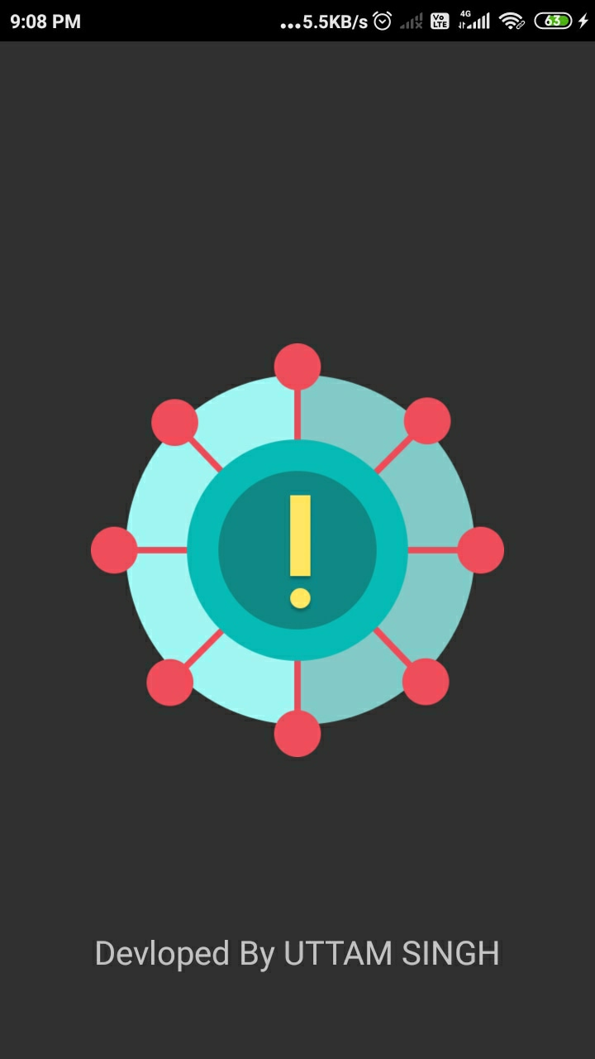

***2Home page***

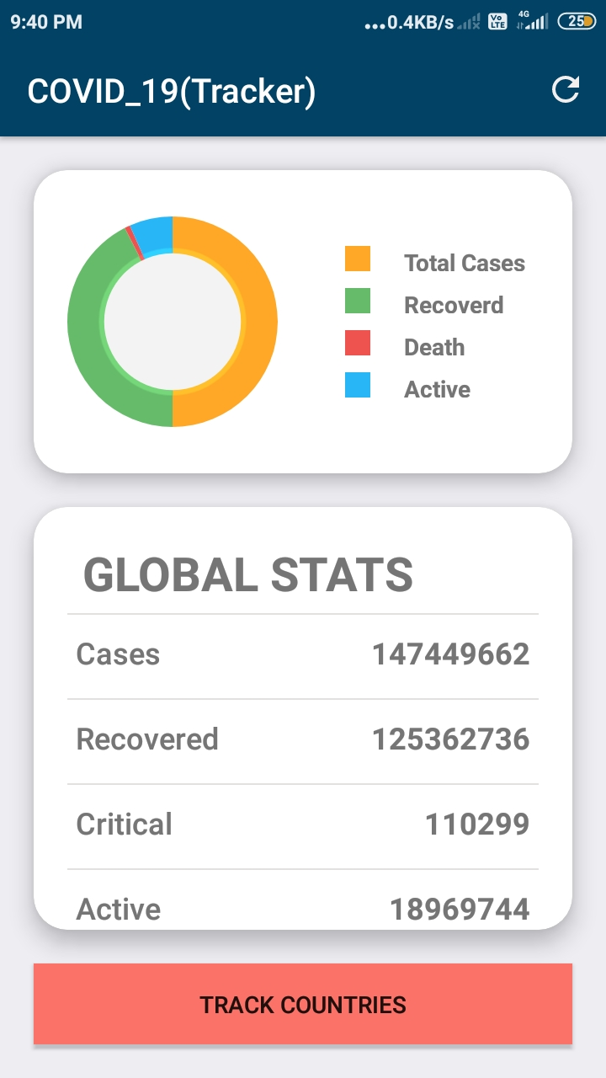

1. ***After Click on Track Country Button***

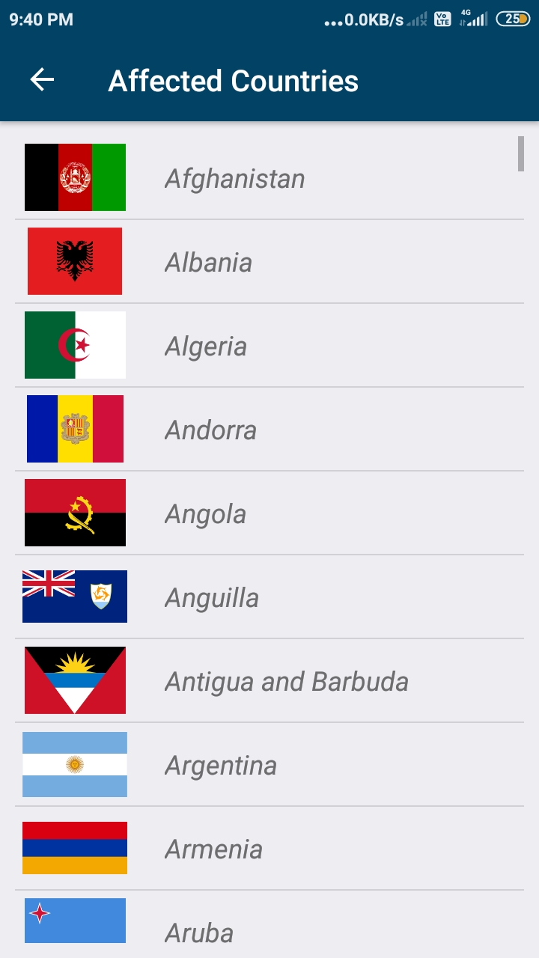

1. ***After Click On a Specific Country i.e India***

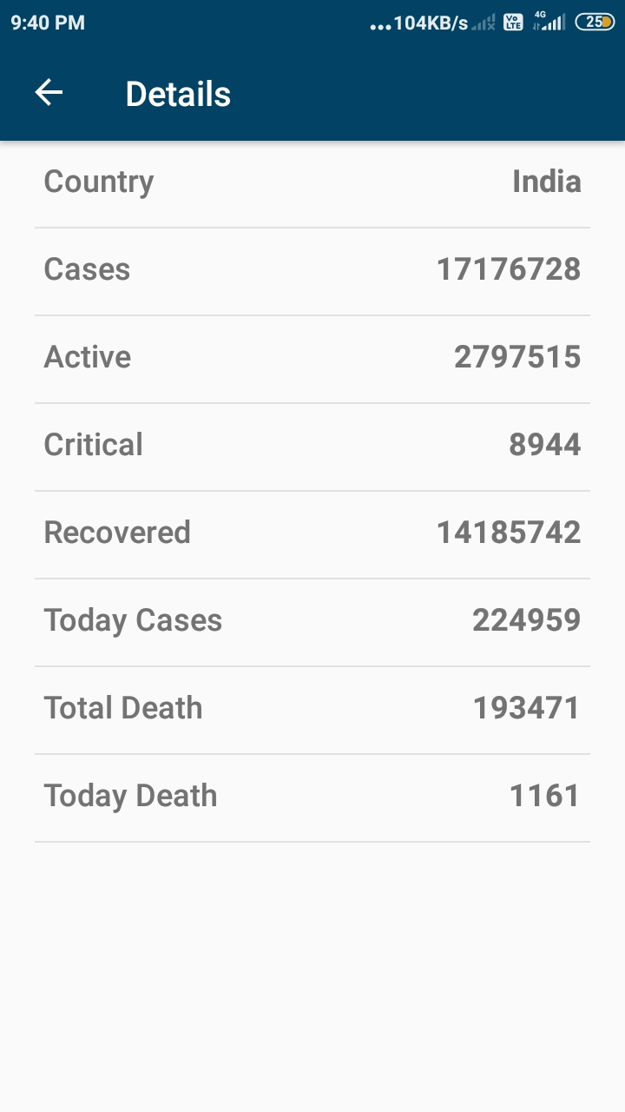

FUTURE ENHANCEMENTS

1. *Show The Country State and territory Data.*
2. *News Features.*
3. *How To Safe From Covid_19.*
4. *Available In Multiple Language.*
5. *Covid center Near You.*

**REFERENCES AND BIBLIOGRAPHY**

I referred to the following links to give functionality to my project:

* **Reference links:**
* [www.google.com](http://www.google.com)
* [www.youtube.com](http://www.youtube.com)
* <https://app.creately.com>
* <https://www.youtube.com/watch?v=_aXztRbUZ80>
* *https://www.youtube.com/watch?v=G6f6lm3ZCTU&t=16s*